ELEE 432 Project 1 report

Theo Stangebye and Stephen Lehman

3/30/2020

**Introduction:**

In this project we assessed the impact of equalization on the performance of data gathered from an underwater optical communications link. Dr. Luke Rumbaugh provided us with the data gathered by a researcher at Naval Air Station Patuxent River, MD. The data described 10 “channels” which were water with different turbidity levels that caused the signal to have link attenuation lengths ranging from 0.188822 cz to 28.8421 cz. We are considering a QAM 16 transmission through these channels with different types of filters and equalizers to see the behavior under different SNR conditions.

**Part 1:**

We started by having an ideal channel transmit 16 QAM. No filters were implemented, as this was the baseline ideal case. The SNR was varied and the bit error rate was measured and plotted in Figure 1. The block diagram for the system is in Figure 2. As the SNR gets lower, the BER increases, as we would expect.

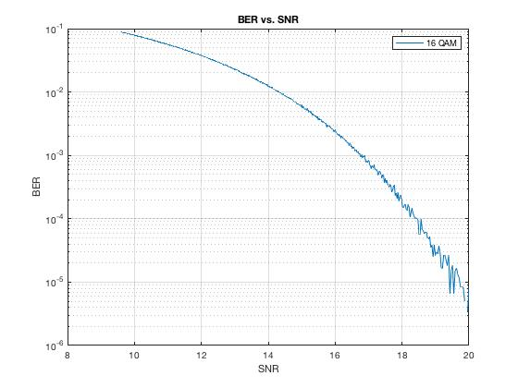

Figure 1: BER vs. SNR for QAM 16 with an Ideal Channel

Bitstream 🡪QAM 16 Modulation🡪Ideal Channel🡪QAM 16 Demodulation🡪 Output

Figure 2:

Block Diagram for QAM 16 with an Ideal Channel

**Part 2:**

Next, we transmitted 16 QAM through 10 non-distorting bandlimited channels, modeling water with increasing turbidities. The filters were implemented from the data given to us by Dr. Rumbaugh “WC”. The lost energy due to the band limiting was calculated with the following lines of code:

loss = Wc(nn)*1e6/1100e6;

lossDB = 10*log10(loss);

The SNR was varied and the bit error rate was measured and plotted in Figure 3. Figure 4 has the ideal case on the same plot. The block diagram for the system is in Figure 5. The channels behaved very similarly, until the turbidity reached 14.4174 cz attenuation length, where the band-limiting increased the BER linearly as the turbidity increased.

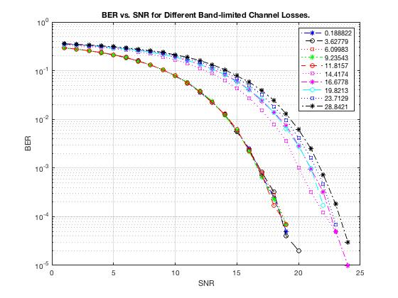

Figure 3: BER vs. SNR for QAM 16 through Channels Band-Limited by Turbidity

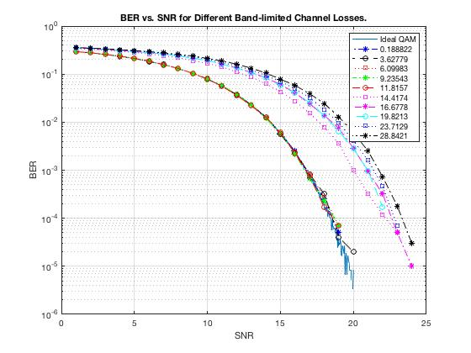

Figure 4:

BER vs. SNR for QAM 16 through Channels Band-Limited by Turbidity with Ideal QAM included

Bitstream 🡪QAM 16 Modulation🡪Band-Limited Channel🡪QAM 16 Demodulation🡪 Output

Figure 5:

Block Diagram for QAM 16 with a Channel Band-Limited by Turbidity

**Part 3:**

Next, we transmitted 16 QAM through 10 distorting channels, modeling water with increasing turbidities, and with transmit and receive filters that were both root raised cosines. The filters were implemented from the communications toolbox, using comm.RaisedCosineTransmitFilter

and comm.RaisedCosineRecieveFilter. The distorting channels were modeled using the following code: (f was provided by Dr. Rumbaugh)

% DISTORTING FILTER DESIGN

f2 = f; % copy freqs

f2(1) = 0; % force first frequency to be 0, DC

dstrt_chnl = fdesign.arbmagnphase('N,F,H',50,f2./(max(f2)),Cf(:,nn)); % estimate channel

dstrt_fltr = design(dstrt_chnl); % construct filter to emulate estimated channel

The SNR was varied and the bit error rate was measured and plotted in Figure 6. The block diagram for the system is in Figure 7. The channels behaved very similarly, with the BER fluctuating around 0.5, showing that the channel distortion uncompensated completely garbled the bitstreams.

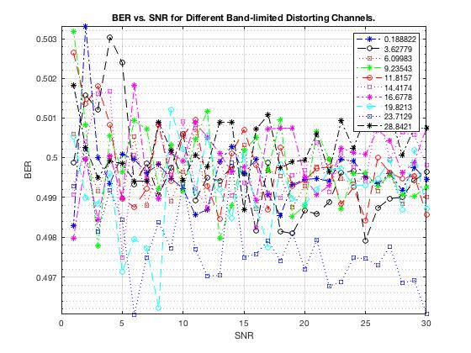

Figure 6:

BER vs. SNR for QAM 16 through Channels Distorted by Turbidity with RRC Filters

Bitstream 🡪QAM 16 Mod🡪TX RRC🡪Distorting Channel🡪RX RRC🡪QAM 16 Demod🡪 Output

Figure 7:

Block Diagram for QAM 16 with a Channel Distorted by Turbidity

**Part 4:**

Next, we transmitted 16 QAM through 10 distorting channels, modeling water with increasing turbidities, and with transmit and receive filters that were both root raised cosines and an equalizer filter before the channel. The equalizing filter was implemented by the following code: (Cf is given by Dr. Rumbaugh, f2 was calculated in previous code)

% full channel eq

eq_mag = 1./abs(Cf(:,nn));

eq_phase = - angle(Cf(:,nn));

eq_real = eq_mag .* cos(eq_phase);

eq_imag = eq_mag .* sin(eq_phase);

eq_coef = complex(eq_real, eq_imag);

equalizer = fdesign.arbmagnphase('N,F,H',200,f2./(max(f2)),1./Cf(:,nn)); % estimate channel

eq_fltr = design(equalizer);

The SNR was varied and the bit error rate was measured and plotted in Figure 8. The block diagram for the system is in Figure 9. The channels behaved very well, until band-limiting hurt the equalization. All channels with a turbidity of less than 9.23543 cz attenuation length performed so well that they didn’t show up on the plots, and all channels with turbidity greater than 11.8157 cz attenuation length had a stable BER of around 0.5 for all SNR values tested.

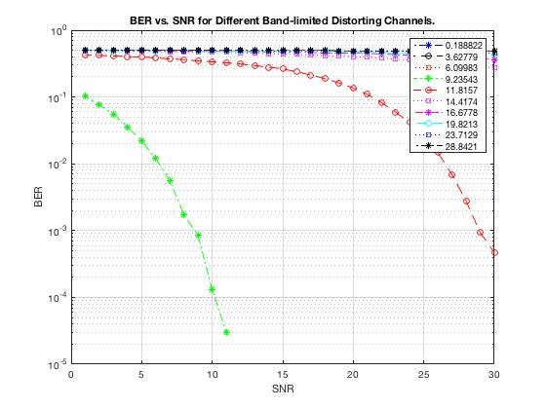

Figure 8:

BER vs. SNR for QAM 16 through Channels Distorted by Turbidity with RRC Filters and an Equalizer

Bitstream🡪QAM 16 Mod🡪TX RRC🡪Equalizer🡪Distorting Chan.🡪RX RRC🡪QAM 16 Demod🡪 Output

Figure 9:

BER vs. SNR for QAM 16 through Channels Distorted by Turbidity with RRC Filters and an Equalizer